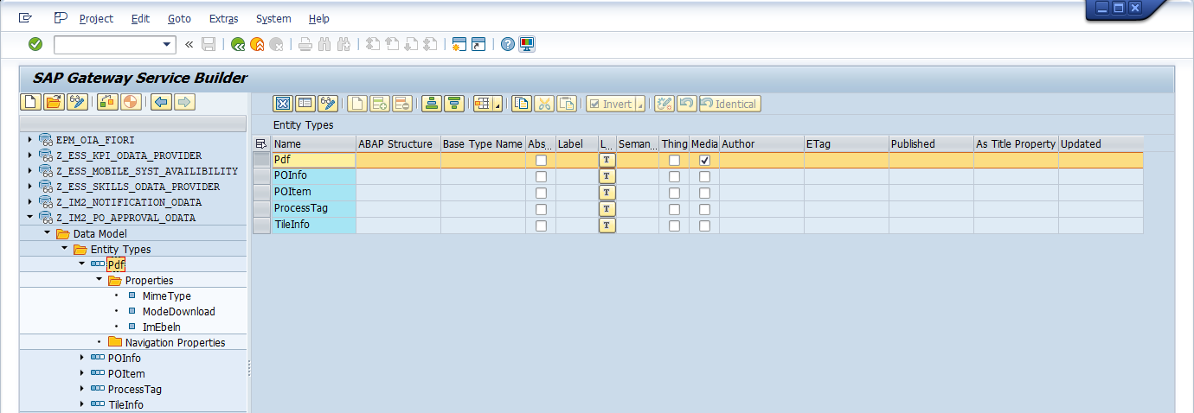

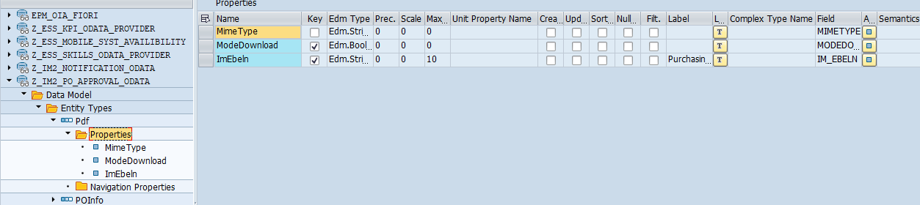

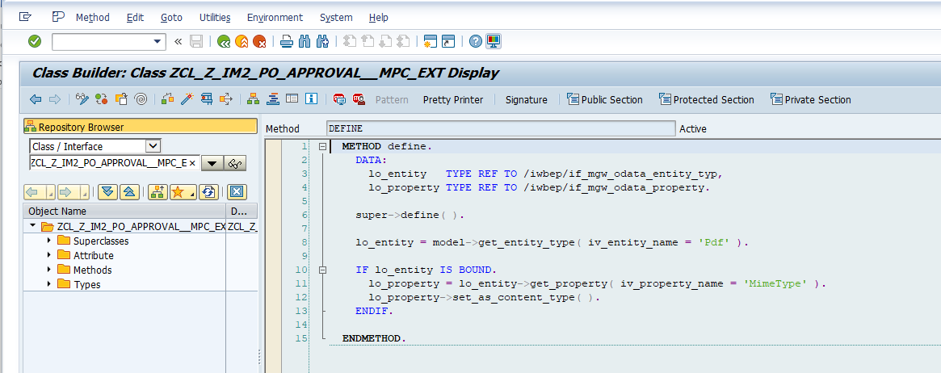

    DATA:  
      lo_entity   TYPE REF TO /iwbep/if_mgw_odata_entity_typ,  
      lo_property TYPE REF TO /iwbep/if_mgw_odata_property.  
  
    super->define( ).  
  
    lo_entity = model->get_entity_type( iv_entity_name = 'Pdf' ).  
  
    IF lo_entity IS BOUND.  
      lo_property = lo_entity->get_property( iv_property_name = 'MimeType' ).  
      lo_property->set_as_content_type( ).  
    ENDIF.

DPC_EXT get_stream redefinition

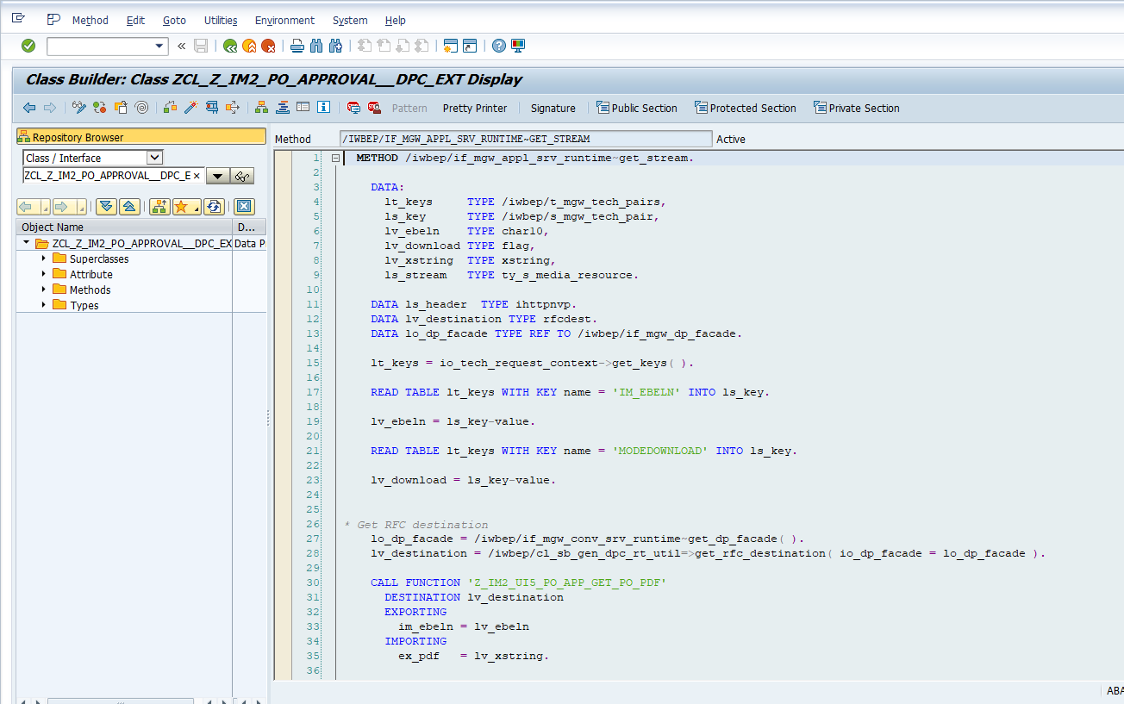

 METHOD /iwbep/if_mgw_appl_srv_runtime~get_stream.  
  
    DATA:  
      lt_keys     TYPE /iwbep/t_mgw_tech_pairs,  
      ls_key      TYPE /iwbep/s_mgw_tech_pair,  
      lv_ebeln    TYPE char10,  
      lv_download TYPE flag,  
      lv_xstring  TYPE xstring,  
      ls_stream   TYPE ty_s_media_resource.  
  
    DATA ls_header  TYPE ihttpnvp.  
    DATA lv_destination TYPE rfcdest.  
    DATA lo_dp_facade TYPE REF TO /iwbep/if_mgw_dp_facade.  
  
    lt_keys = io_tech_request_context->get_keys( ).  
  
    READ TABLE lt_keys WITH KEY name = 'IM_EBELN' INTO ls_key.  
  
    lv_ebeln = ls_key-value.  
  
    READ TABLE lt_keys WITH KEY name = 'MODEDOWNLOAD' INTO ls_key.  
  
    lv_download = ls_key-value.  
  
  
* Get RFC destination  
    lo_dp_facade = /iwbep/if_mgw_conv_srv_runtime~get_dp_facade( ).  
    lv_destination = /iwbep/cl_sb_gen_dpc_rt_util=>get_rfc_destination( io_dp_facade = lo_dp_facade ).  
  
    CALL FUNCTION 'Z_IM2_UI5_PO_APP_GET_PO_PDF'  
      DESTINATION lv_destination  
      EXPORTING  
        im_ebeln = lv_ebeln  
      IMPORTING  
        ex_pdf   = lv_xstring.  
  
    ls_stream-value = lv_xstring.  
  
    ls_stream-mime_type = 'application/pdf'.  
    ls_header-name = 'content-disposition'.  
  
    IF lv_download IS INITIAL.  
      ls_header-value = 'inline; filename=entity.pdf'.  "PDF opened directly  
    ELSE.  
      ls_header-value = 'attachment; filename=entity.pdf'."PDF will be downloaded  
    ENDIF.  
  
    /iwbep/if_mgw_conv_srv_runtime~set_header( ls_header ).  
  
    copy_data_to_ref( EXPORTING is_data = ls_stream  
                      CHANGING  cr_data = er_stream ).  
  
  ENDMETHOD.

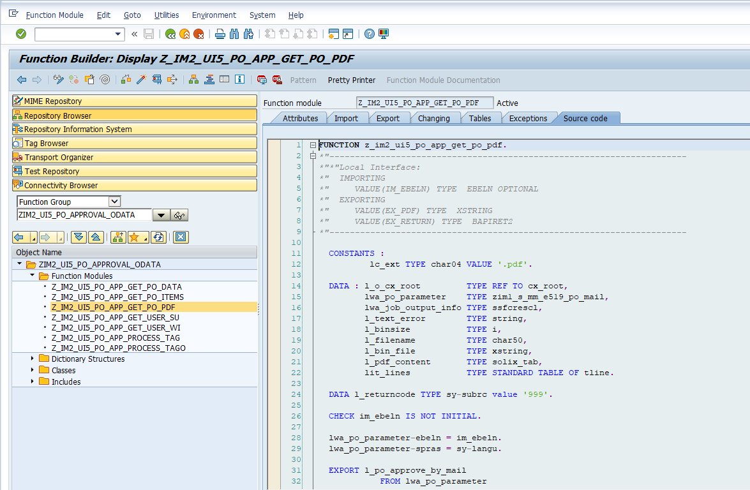

FUNCTION z_im2_ui5_po_app_get_po_pdf.  
*"----------------------------------------------------------------------  
*"*"Local Interface:  
*"  IMPORTING  
*"     VALUE(IM_EBELN) TYPE  EBELN OPTIONAL  
*"  EXPORTING  
*"     VALUE(EX_PDF) TYPE  XSTRING  
*"     VALUE(EX_RETURN) TYPE  BAPIRET2  
*"----------------------------------------------------------------------  
  
  CONSTANTS :  
          lc_ext TYPE char04 VALUE '.pdf'.  
  
  DATA : l_o_cx_root         TYPE REF TO cx_root,  
         lwa_po_parameter    TYPE zim1_s_mm_e519_po_mail,  
         lwa_job_output_info TYPE ssfcrescl,  
         l_text_error        TYPE string,  
         l_binsize           TYPE i,  
         l_filename          TYPE char50,  
         l_bin_file          TYPE xstring,  
         l_pdf_content       TYPE solix_tab,  
         lit_lines           TYPE STANDARD TABLE OF tline.  
  
  DATA l_returncode TYPE sy-subrc value '999'.  
  
  CHECK im_ebeln IS NOT INITIAL.  
  
  lwa_po_parameter-ebeln = im_ebeln.  
  lwa_po_parameter-spras = sy-langu.  
  
  EXPORT l_po_approve_by_mail  
            FROM lwa_po_parameter  
            TO MEMORY ID zcl_im2_mm_e519_enha_notif=>c_memid_zpoappmail.  
  
  SELECT * FROM nast UP TO 1 ROWS  
                     WHERE kappl EQ 'EF'  
                       AND objky EQ im_ebeln.  
  ENDSELECT.  
  
  SELECT SINGLE * FROM tnapr  
                   WHERE kschl EQ nast-kschl  
                     AND nacha EQ nast-nacha  
                    AND kappl EQ nast-kappl.  
  
  CHECK sy-subrc EQ 0.  
  
  PERFORM entry IN PROGRAM zim1_mm_print_po_print USING l_returncode  
                                                     'X'  
                                                     IF FOUND.  
  IF l_returncode = 0.  
  
    " Export is done in report ZIM1_MM_PRINT_PO_PRINT.  
    IMPORT lit_otf_data  
            TO lwa_job_output_info-otfdata  
            FROM MEMORY ID zcl_im2_mm_e519_enha_notif=>c_memid_zpoappmail_otf.  
  
    IF sy-subrc = 0.  
  
      CALL FUNCTION 'CONVERT_OTF'  
        EXPORTING  
          format                = 'PDF'  
        IMPORTING  
          bin_filesize          = l_binsize  
          bin_file              = ex_pdf  
        TABLES  
          otf                   = lwa_job_output_info-otfdata  
          lines                 = lit_lines  
        EXCEPTIONS  
          err_max_linewidth     = 1  
          err_format            = 2  
          err_conv_not_possible = 3  
          err_bad_otf           = 4  
          OTHERS                = 5.  
  
      IF sy-subrc NE 0.  
  
      ENDIF.  
    ENDIF.  
  ENDIF.  
  
  FREE MEMORY ID zcl_im2_mm_e519_enha_notif=>c_memid_zpoappmail.  
  
ENDFUNCTION.